**Task 10**

**Task description:** Create a Dockerfile for a sample Node.js application and automate the process of building the Docker image and pushing it to Docker Hub using Jenkinsfile.

🡪I did the task in AWS cloud.

**Step 1:** create a EC2 instance.

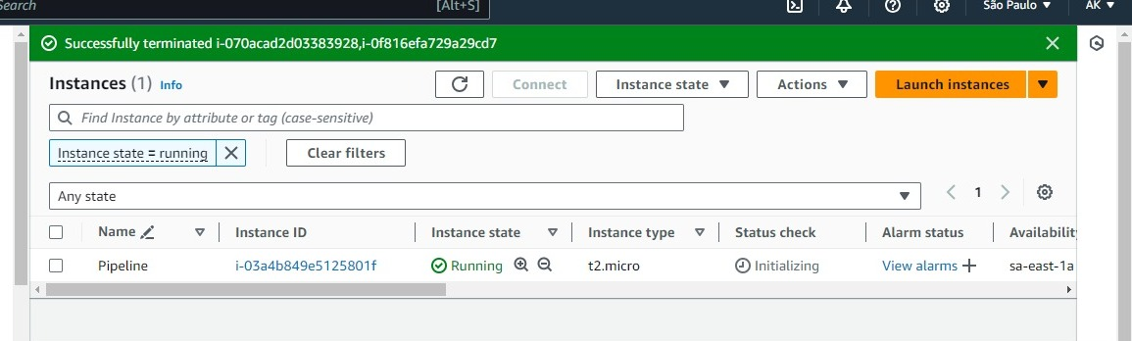

**Step 2:** Login to git bash through key pair and connect. Now, install java, docker, jenkins and check the java version.

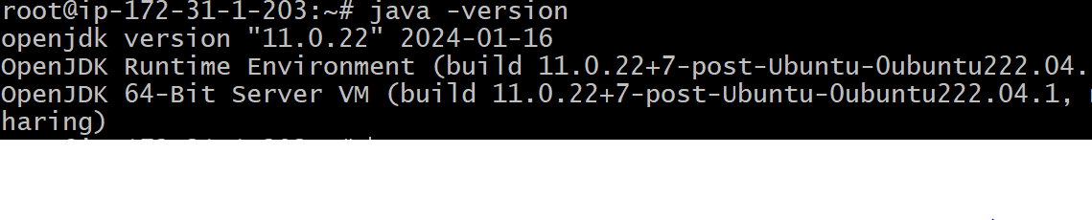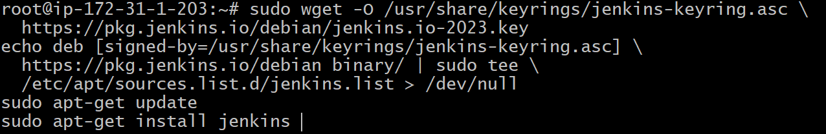

After installing Jenkins, go to the instance and copy the IP address & open it in new tab including port number – 8080.

Now my server was connected to the Jenkins.

**Step 3:** Unlock the Jenkins by using password.

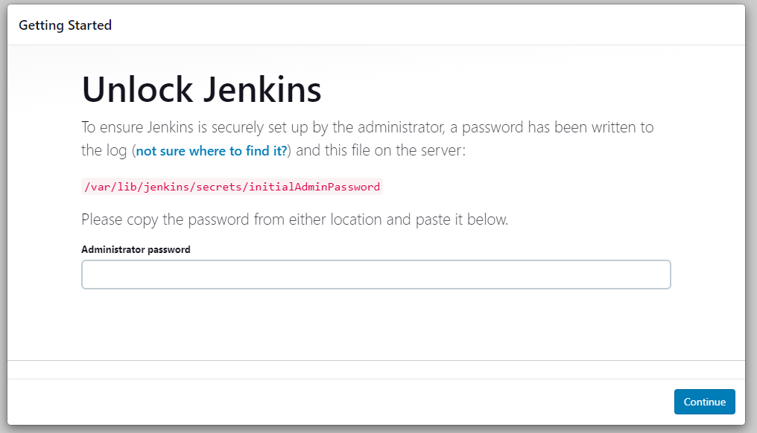



Install suggested plugins.

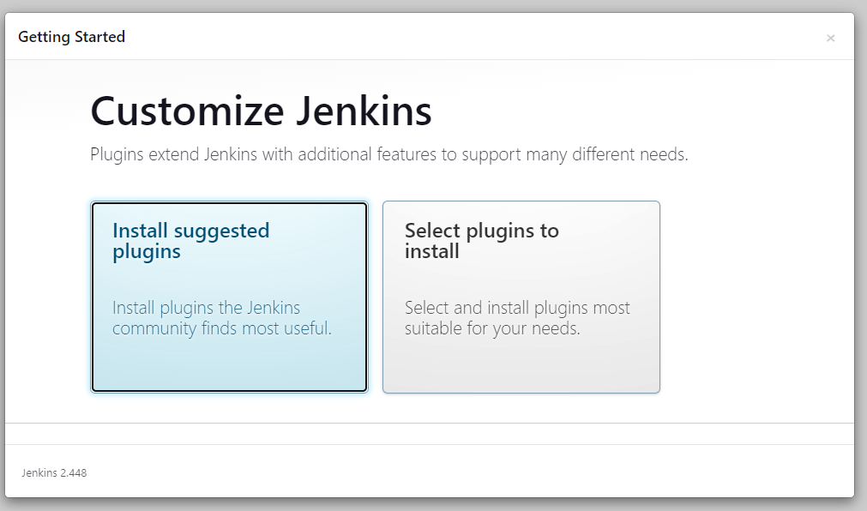

**Step 4:** Now create username and password.

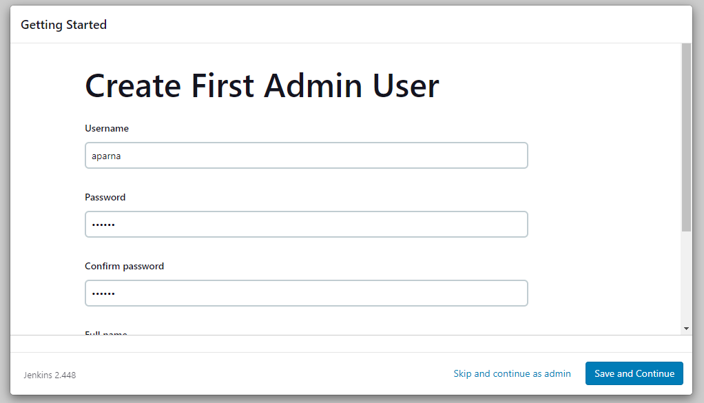

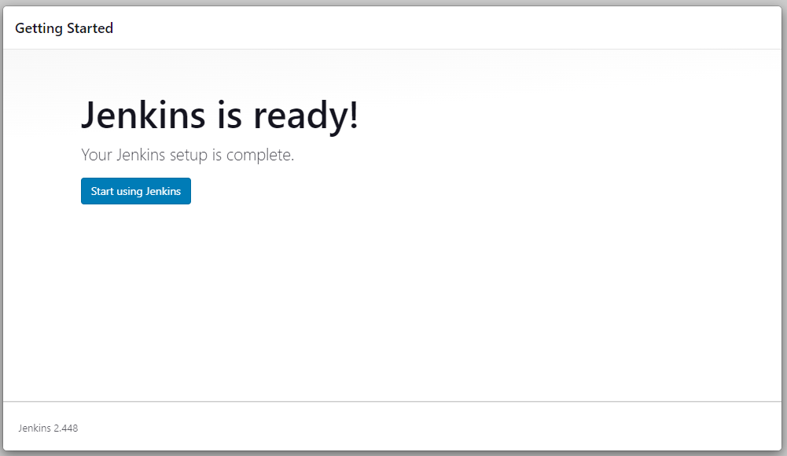

**Step 5:** here I create 2 plugins- nodeJS and docker pipeline.

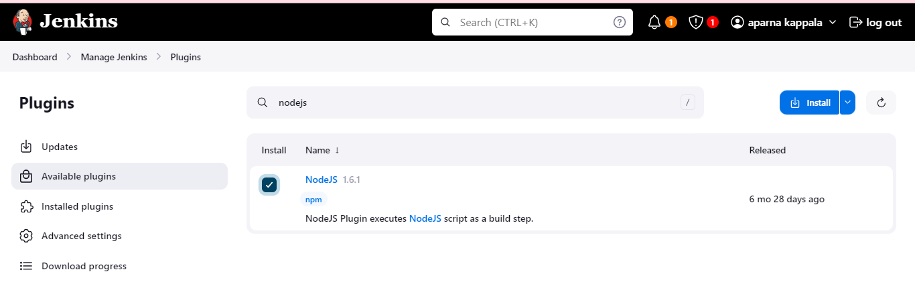

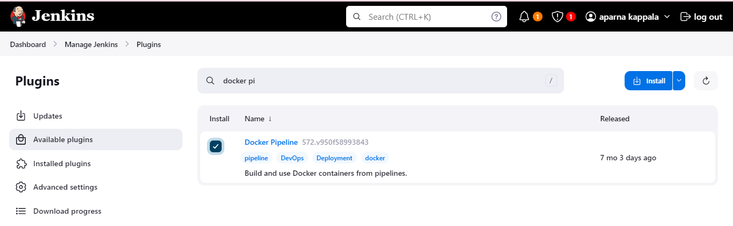

Now I created credentials.

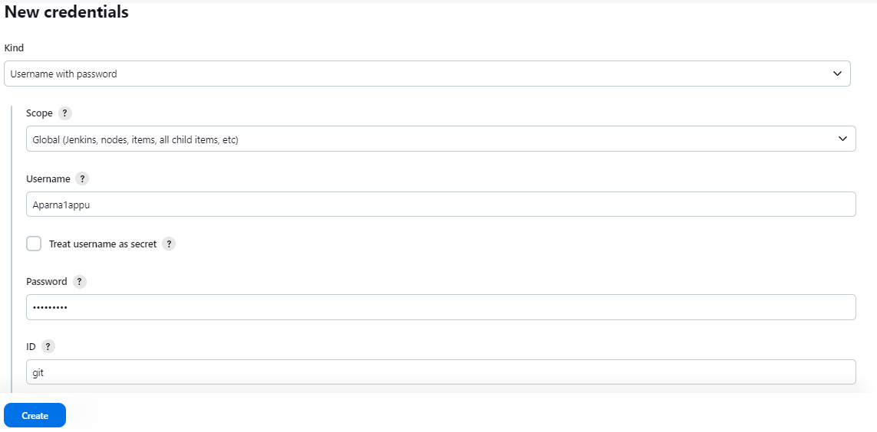

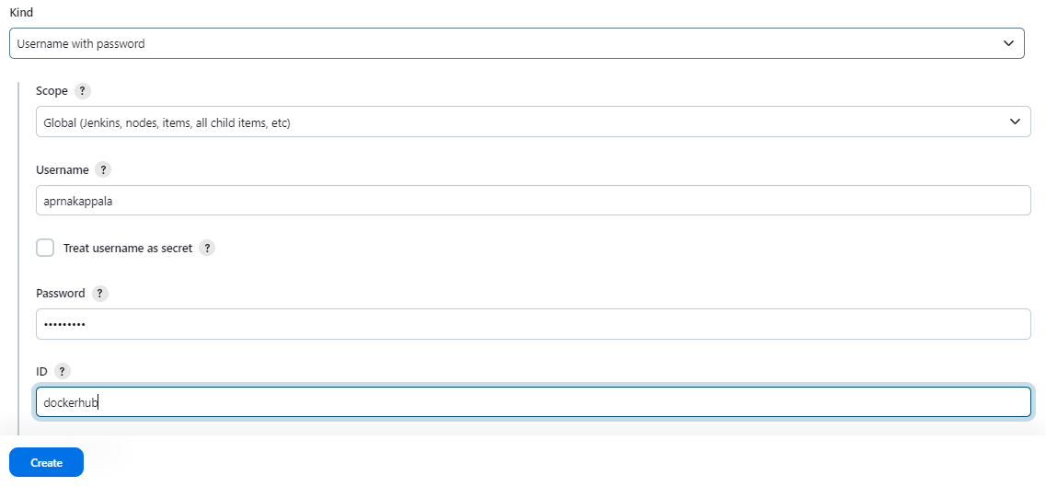

**Step 6:** Now install docker slave configuration by using these commands.

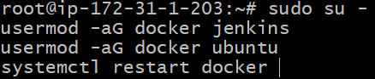

**Step: 7** Now create a job and choose pipeline, enter the item name.

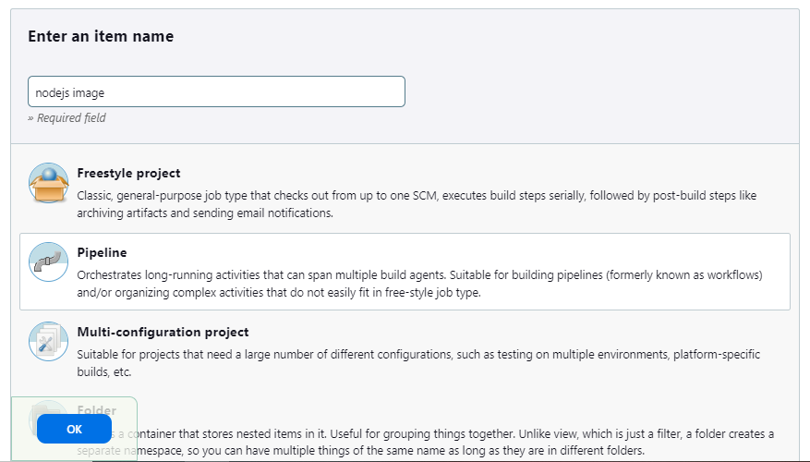

**Step 8:** Fill the details and jenkinsfile is my repository URL.

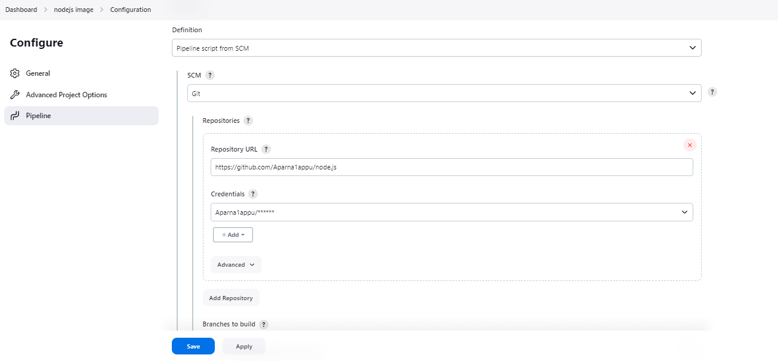

My Pipeline is successfully builded.

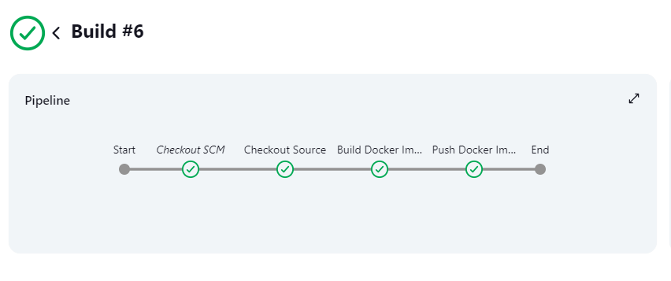

Finally my docker image is pushed to dockerhub.

